NEXT JS 1
It’s a React Framework it gives you routing, server rendering, api routes, image optimization
Ans everything you need to know to make your website rank superhigh in SEO
Starting Project
npx create-next-app

FOLDER STRUNCTURE ADDED
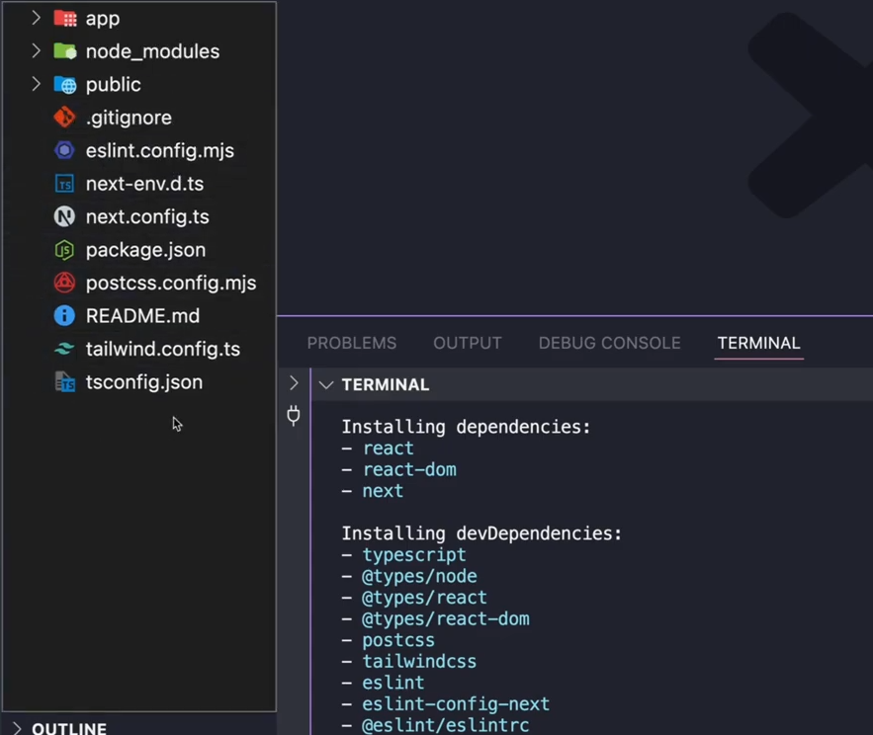
Next.config.ts file - Its used for costumizing and configuring anything in your app ranging from environment variables to your build instructions
Working with NextJS you can forget libraries like react-router-dom
In NextJS Routing is done in your file system
There are two types of routing
- App router
- Pages Router
APP ROUTER
Allows you to create a route by simply creating a folder with the name of the route and render a component inside of page.tsx file inside of that folder
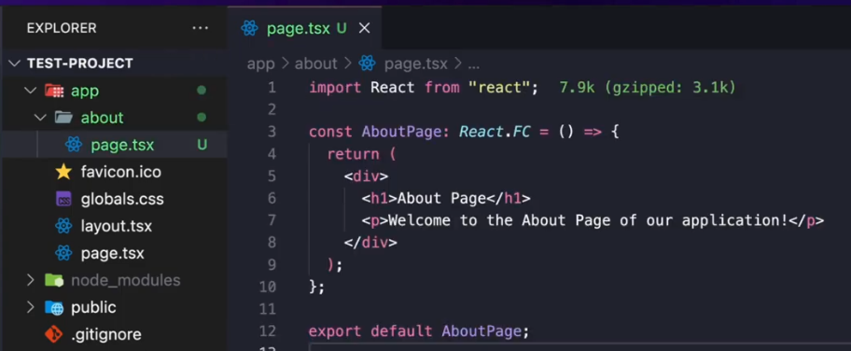
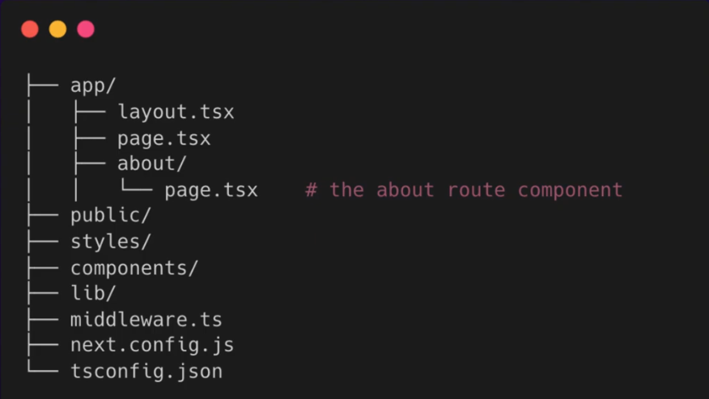

PAGE ROUTER
You have a folder called pages and whatever file or folder you put in it the name of that file will became a route
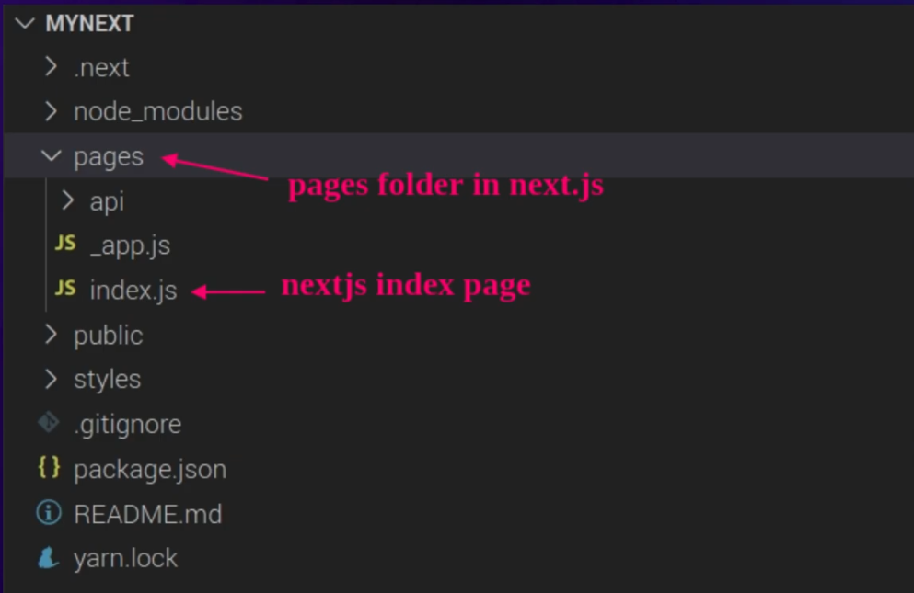

Btn There two options the app router is the most scalable option
And the pages router has become legacy since nextJS13

By default components in the app folder are server components this means that they run on ther server and only send HTML to the client super fast
This means that in server components you don’t have access to current browser features like onclick BUTTON

When you need Interactivity like all the HOOKS and onClick You need a client component and you can do that by just adding the use client on top of the component
Use client;
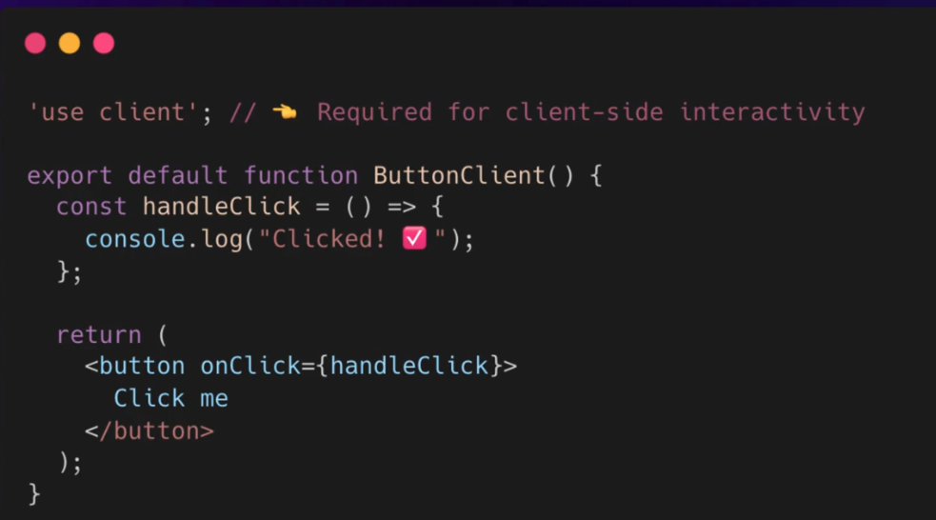
This will tell nextJS to render it on the client then you can actually call these component inside the server component 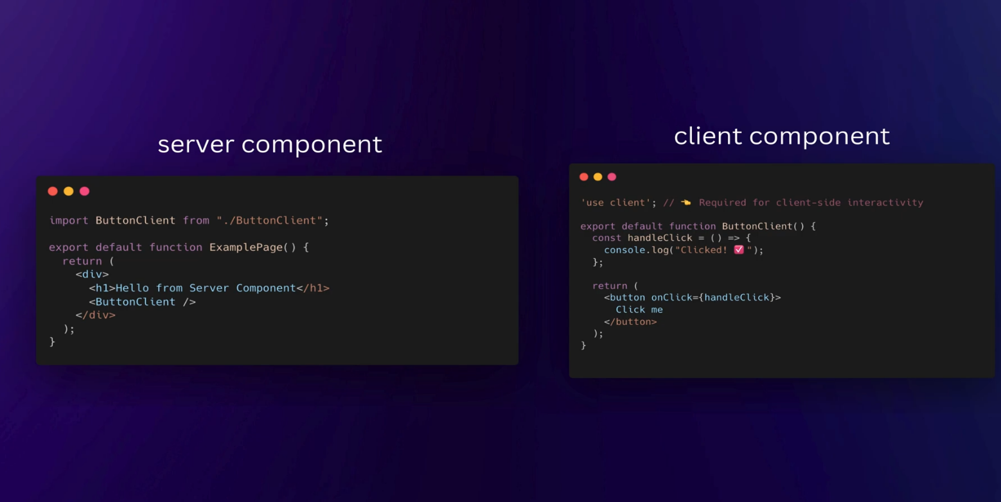
So the idea is you have a server component for your route your page and then you have the client component that you call on the server whenever you need staff like event listeners or hooks or browser interactivity

NOW WHY SERVER COMPONENTS
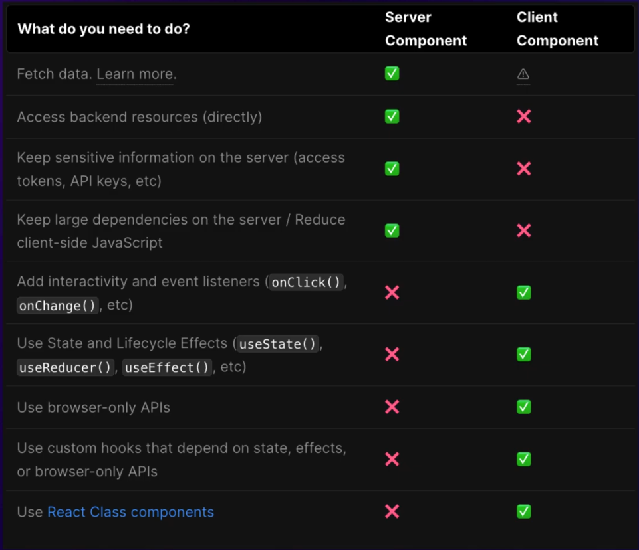
HELPING best for performance and SEO because they allow users to get faster initial page load
Due to having less JS being sent to the browser and also since server components have
pre-rendered HTML search Enging clawlers from google EG kan easily find Keywords to rank your website higher

WHAT ABOUT FETCHING DATA
There is no need of using axios,fetchAPI and useEffect Hook
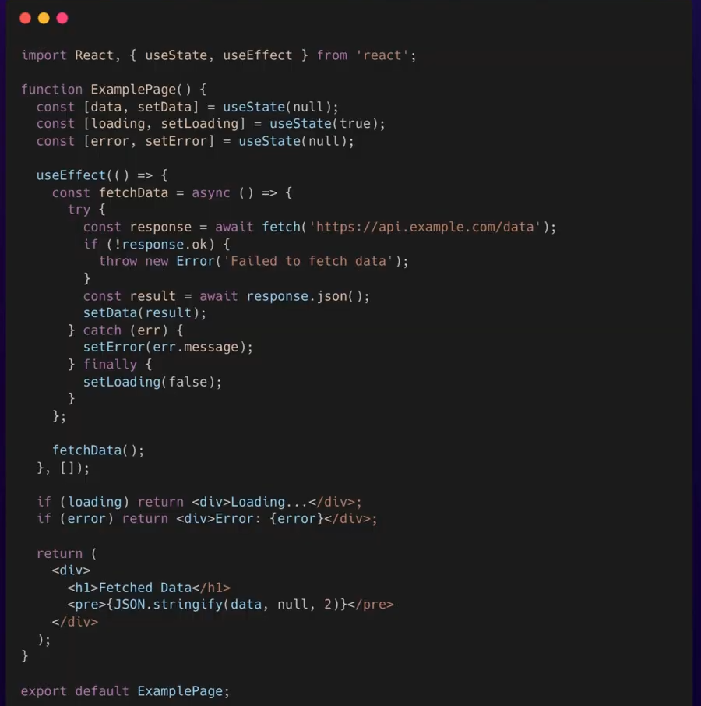
In NextJS You can do it Directly inside of your component by making you component being an async function and just use the await inside of it
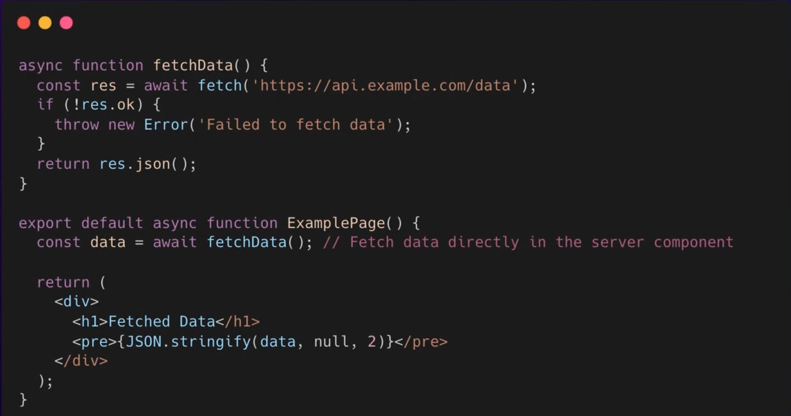
NEXT Will handle caching, Revalidating and Loading the UI for you
If you wanna actually create a loading state for when the data is loading You can simply create a loading.tsx file in the same folder that you created the route that is fetching that data
And whenever the info is loading that component will be rendered
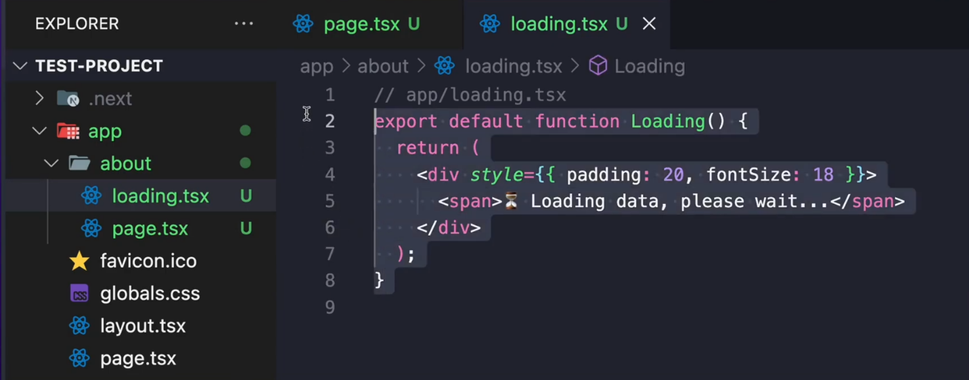

In the Previous Example I Called a public API
But in NextJS you can create Create your own API directly in the project using API ROUTES
To create an API endpoint you simply make a folder called API
And every folder you put inside of it with the file called route.ts will become an apiEnd point
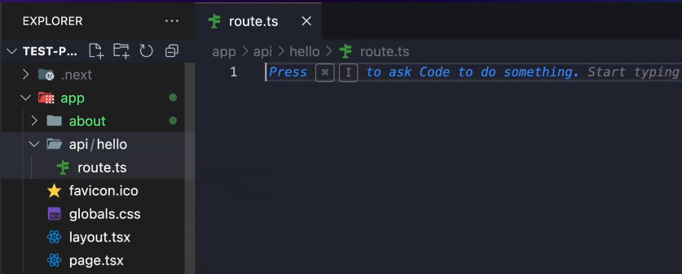
Example Here is the Hellow folder which is inside the API folder and in the route.ts file
I have created GET,POST,PUT and DELETE functions inside of it to handle the different HTTP methods that that API route will handle
And you can see that you can handle everything that an API would require without even needing EXPRESS and its all handles in the same project that you are doing your frontend

And Other Cool thing is that NextJS is Built To Optimize for you
It means even simple things like rendering an image is way better
In NextJS you use that image component and it will automatically compress and lazyload images for you
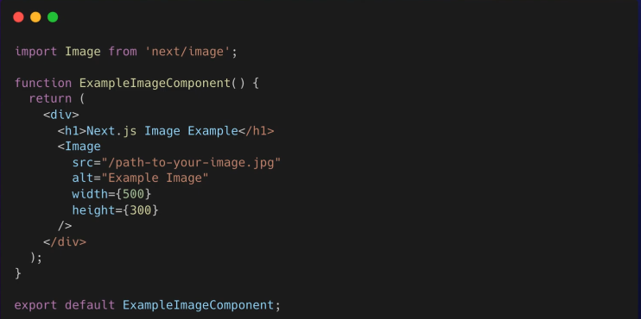
This will improve performance without you even doing anything

Finally One of the main Advantage of using next is the SEO Benefits
For every single route I make on next project am able to cleary define SEO metadata for IT
Example
If am creating a website and I want to make an about us page that part is important because it have a lot of high ranking keywords and info about my website that would help it RANK
So I can easily set SEO metadata like the title ,description and even keywords like this
